**SQL ASSIGNMENT**

**Query 4**

1. **Display the details of THOSE WHO are drawing the same salary.**

**Query:** SELECT NAME, SALARY FROM PROGRAMMER WHERE SALARY = any(SELECT SALARY FROM PROGRAMMER P GROUP by SALARY HAVING SALARY=P.SALARY AND COUNT(*)>1);

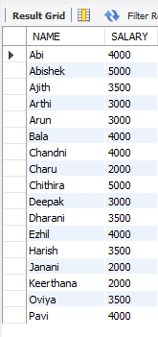

1. **Display the details of software developed by male programmers earning MORE than 3000.**

**Query**: SELECT * FROM PROGRAMMER P,SOFTWARE S WHERE P.NAME=S.NAME AND P.SALARY>3000 AND P.SEX='M';

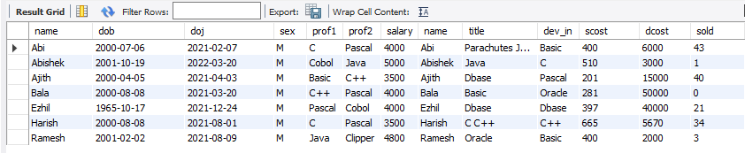

1. **Display details of packages developed in PASCAL by female programmers.**

**Query:** SELECT s.* FROM PROGRAMMER P,SOFTWARE S WHERE P.NAME=S.NAME AND SEX='F' AND DEV_IN='Pascal';

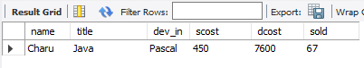

1. **Display the details of the programmer WHO joined BEFORE 1990.**

**Query:** SELECT * FROM PROGRAMMER WHERE date_format(DOJ,'YY')<90;

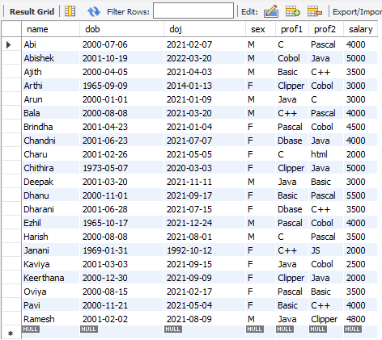

1. **Display details of software developed in C by female programmers of PRAGATHI.**

**Query:** SELECT s.* FROM SOFTWARE S,STUDIES ST,PROGRAMMER P WHERE S.NAME=ST.NAME AND P.NAME=S.NAME AND SEX='F' AND Splace='Pragathi';

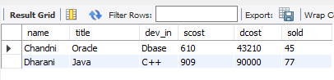

1. **Display NUMBER of packages NUMBER of copies sold and sales value of EACH programmer Institute-wise.**

**Query:** SELECT STUDIES.Splace, COUNT(SOFTWARE.DEV_IN), COUNT(SOFTWARE.SOLD), SUM(SOFTWARE.SOLD*SOFTWARE.SCOST) FROM SOFTWARE,STUDIES WHERE SOFTWARE.NAME=STUDIES.NAME GROUP BY STUDIES.Splace;

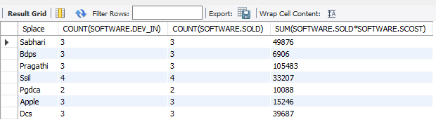

1. **Display details of software developed in DBASE by male programmers WHO belong to the institute on which MOST NUMBER OF programmer’s studies.**

**Query:** SELECT SOFTWARE.* FROM PROGRAMMER,SOFTWARE,STUDIES WHERE PROGRAMMER.NAME=SOFTWARE.NAME AND SOFTWARE.NAME=STUDIES.NAME AND PROGRAMMER.NAME=STUDIES.NAME AND SEX='m' AND DEV_IN='dbase' AND splace= (SELECT splace FROM STUDIES GROUP by splace HAVING COUNT(splace) =(SELECT max(COUNT(splace))FROM STUDIES GROUP by splace));

1. **Display the details of the software that was developed by male programmers born BEFORE 1965 and female programmers born AFTER 1975.**

**Query:** SELECT SOFTWARE.* FROM PROGRAMMER P,SOFTWARE s WHERE s.NAME=P.NAME AND SEX='m' AND to_char(DOB,'yy')<64 or SEX='f' AND To_char(DOB,'yy')>75);

1. **Display the details of the software that was developed in the language that is NOT the programmer’s first proficiency.**

**Query:** SELECT distinct S.* FROM SOFTWARE S, PROGRAMMER P WHERE P.Prof1 <> S.DEV_IN AND S.NAME = P.NAME;

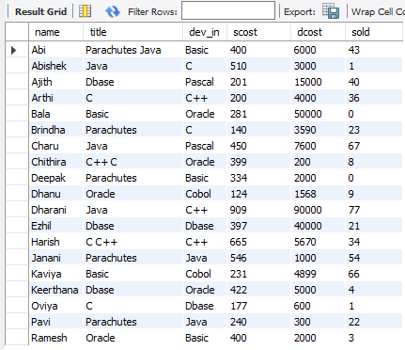

1. **Display details of software that was developed in the language which is NEITHER first NOR second proficiency of the programmer.**

**Query**: SELECT s.* FROM PROGRAMMER P,SOFTWARE s WHERE s.NAME=P.NAME AND (DEV_IN <> Prof1 AND DEV_IN <> Prof2);

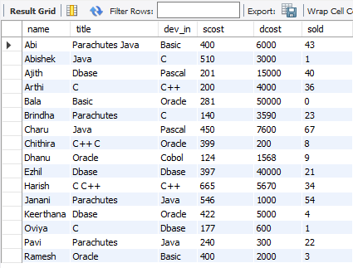

1. **Display details of software developed by male students of SABHARI.**

**Query:** SELECT s.* FROM PROGRAMMER P,SOFTWARE s,STUDIES st WHERE P.NAME=s.NAME AND s.NAME=st.NAME AND SEX='M' AND splace='sabhari';

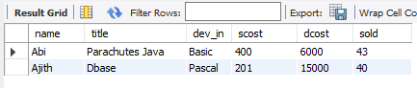

1. **Display the names of programmers WHO HAVE NOT developed any package.**

**Query**: SELECT NAME FROM PROGRAMMER WHERE NAME not in(SELECT NAME FROM SOFTWARE);

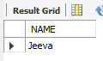

1. **What is the total cost of the software developed by the programmers by APPLE?**

**Query:** SELECT SUM(SCOST) FROM SOFTWARE s,STUDIES st WHERE s.NAME=st.NAME AND splace='apple';

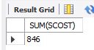

1. **Who are the programmers WHO JOINED in the same day?**

**Query:** SELECT a.NAME,a.DOJ FROM PROGRAMMER a,PROGRAMMER b WHERE a.DOJ=b.DOJ AND a.NAME <> b.NAME;

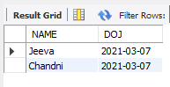

1. **Who are the programmers WHO HAVE THE SAME PROF2?**

**Query:** SELECT NAME FROM PROGRAMMER WHERE Prof2 = any(SELECT Prof2 FROM PROGRAMMER GROUP by Prof2 HAVING COUNT(*) >1);

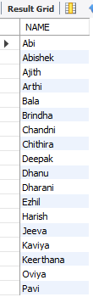

1. **Display the total sales values of software, institutes-wise.**

**Query:** SELECT STUDIES.splace,SUM(SOFTWARE.SOLD*SOFTWARE.SCOST) FROM SOFTWARE,STUDIES WHERE STUDIES.NAME=SOFTWARE.NAME GROUP by STUDIES.splace;

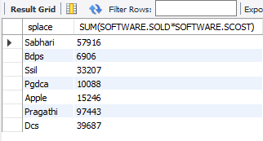

1. **In which institutes did the person who developed the COSTLIEST package study?**

**Query:** SELECT splace FROM SOFTWARE st,STUDIES s WHERE s.NAME=st.NAME GROUP by splace,DCOST HAVING max(DCOST)=(SELECT max(DCOST) FROM SOFTWARE);

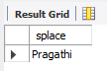

1. **Which language listed in prof1 and prof2 HAS NOT BEEN used to develop any package?**

**Query:** SELECT Prof1 FROM PROGRAMMER WHERE Prof1 not in(SELECT DEV_IN FROM SOFTWARE) union SELECT Prof2 FROM PROGRAMMER WHERE Prof2 not in(SELECT DEV_IN FROM SOFTWARE);

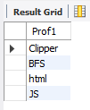

1. **How much does the person WHO developed the HIGHEST selling package earn and WHAT course did he/she undergo?**

**Query:** SELECT P1.SALARY,s2.course FROM PROGRAMMER P1,SOFTWARE s1,STUDIES s2 WHERE P1.NAME=s1.NAME AND s1.NAME=s2.NAME AND SCOST=(SELECT max(SCOST) FROM SOFTWARE);

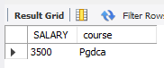

1. **How many months will it take for each programmer to recover the cost of the course underwent?**

**Query:** SELECT P.NAME,ceil(ccost/SALARY) FROM PROGRAMMER P,STUDIES s WHERE s.NAME=P.NAME;

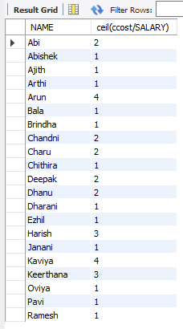

1. **Which is the COSTLIEST package developed by a person with under 3 year’s expenences?**

**Query:** SELECT x.title FROM SOFTWARE x, PROGRAMMER y WHERE (datediff (current _ d ate, y.DOJ)/12) > 3 AND x.NAME=y.NAME;

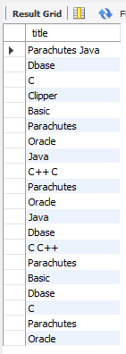

1. **What is the AVERAGE salary for those WHOSE software's sales value is more than 50,000?**

**Query:** SELECT avg(SALARY) FROM PROGRAMMER P,SOFTWARE s WHERE P .NAME=s.NAME AND SOLD*SCOST>50000;

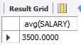

1. **How many packages were developed by the students WHO studied in the institute that Charge the LOWEST course fee?**

**Query:** SELECT COUNT(s.NAME) FROM SOFTWARE s,STUDIES st WHERE s.NAME=st.NAME GROUP by s.NAME,ccost HAVING min(ccost)=(SELECT min(ccost) FROM STUDIES);

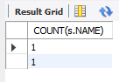

1. **How many packages were developed by the person WHO developed the CHEAPEST package? Where did he\she study?**

**Query:** SELECT COUNT(*) FROM PROGRAMMER P,SOFTWARE s WHERE s .NAME=P.NAME GROUP by DEV_IN HAVING min(DCOST)=(SELECT min(DCOST) FROM SOFTWARE);

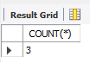

1. **How many packages were developed by female programmers earning MORE than the HIGHEST paid male programmer?**

**Query:** SELECT COUNT(DEV_IN) FROM PROGRAMMER P,SOFTWARE s WHERE s.NAME=P.NAME AND SEX='f' AND SALARY>(SELECT max(SALARY) FROM PROGRAMMER P,SOFTWARE s WHERE s.NAME=P.NAME AND SEX='m');

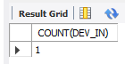

1. **How many packages were developed by the MOST experienced programmers from BDPS?**

**Query:** SELECT COUNT(*) FROM SOFTWARE S,PROGRAMMER P where P.NAME=S.NAME GROUP BY DOJ HAVING MAX(DOJ)=(select MAX(DOJ) FROM STUDIES ST,PROGRAMMER P, SOFTWARE S WHERE P.NAME=S.NAME and ST.NAME=P.NAME AND (splace='bdps'));

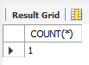

1. **List the programmers (from software table) and institutes they studied, including those WHO DIDN'T develop any package.**

**Query:** SELECT NAME,splace FROM STUDIES WHERE NAME not in(SELECT NAME FROM SOFTWARE);

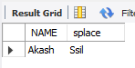

1. **List each profit with the number of programmers having that prof1 and the number of packages developed in that prof1.**

**Query:** SELECT COUNT(*),SUM(SCOST*SOLD-DCOST) "PROFIT" FROM SOFTWARE WHERE DEV_IN in (SELECT Prof1 FROM PROGRAMMER) GROUP by DEV_IN;

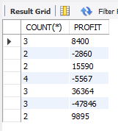

1. **List programmer names (from programmer table) and number of packages EACH developed.**

**Query:** SELECT s.NAME,COUNT(DEV_IN) FROM PROGRAMMER P1,SOFTWARE s WHERE P1.NAME=s.NAME GROUP by s.NAME;

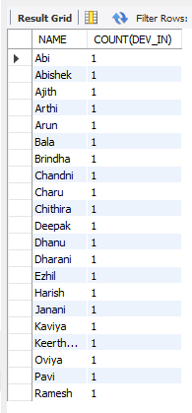

1. **List all the details of programmers who have done a course at S.S.I.L.**

**Query:** select programmer.* from programmer,software,studies where splace='S.S.I.L' and programmer.name=software.name and programmer.name=studies.name and studies.splace='s.s.i.l';

